**E-PROJECT DEVELOPMENT TEAM**

* **star organic farm**
* **TEAM MEMBERS**
* Hazim Hassan
* Hayan Raza
* Saim Rizwan
* **PROFESSOR NAME**
* Hammad Hassan
* **BATCH CODE**
* PR2-20246E1
* **SEMESTER**
* ADSE

*CERTIFICATE OF COMPLETION*

This is to certify that Syed Usama, & Syed Ayan ali have successfully completed their ACCP 1st Semester (CPISM) E-Project.

Submitted to: Aptech Computer Education

On

feb-2-2024

ACKNOWLEDGMENT

A quick responsive team with a friendly environment yet consistent pace of work is what the world demands from us IT professionals. However, in a situation like now busy schedules and abstracted locations become a known barrier for causing a delay in the submissions of most of the project, forcing us to grasp better and more effective alternatives to prove our efficiencies.

We would like to acknowledge all those who have given moral support and helped me make the project a success.

Also we would like to express our teacher **Hammad Hassan** for his guidance and constant supervision as well as providing necessary information regarding the project.

I also express my sincere gratitude to the E-project Team at the Aptech Head Office.

ABRIDGEMENT

We worked for almost a week so the venture we started could come to an end. During this span of time my team and I faced some completely unpredictable complications which enhanced our knowledge about coding errors and its omissions. We failed on certain points however at last we advanced to the final progress.

PROBLEM STATEMENT

**Star Organic farm is commenced in the year 1988. Company is involved in trading and manufacturing a wide range of Organic Products and spices to the consumers all around the global market. Company has wide variety of collection of products lies of Nutritious cereals, Pulses, Spices and Condiments, Cooking Oils, Fruit Pulps, Agro Products, Oils, Wheat and Wheat Flour, Rice and Rice products and so on.**

**Requirement Specification:**

The Web site is to be created based on the following requirements.

1) The Home Page should be created making use of Sections with a suitable logo of STAR BRAND.

2) Links such as Home, Products, Contact Us, Query, Show case gallery must be included.

3) The Products must be properly categorized and details of each product must be presented with suitable size image.

4) For each information section of the products the enquiry and order link must be provided.

5) Contact us page must be included.

6) Navigation must be made smoother.

7) Uniformity in the designing must be maintained in the application.

8) Images must be defined with alt attribute defined.

Hardware/ Software Requirements

**Hardware**

* A minimum computer system that will help you access all the tools in the courses is a Pentium 166 or better
* 64 Megabytes of RAM or better

**Software *[Either or Combination as per Course/Sem]***

* Notepad/HTML editor
* Dreamweaver
* IE 5.0/ Netscape 6.0

# Architecture and Design of the System DEVELOPERS GUIDE

Using HTML, CSS, BOOTSTRAP and JAVA SCRIPT on this project was a very convenient yet a simple way to express our creativity in different sorts of manner. This website is based on various classes and ids set in a consecutive manner with suitable names and a very readable coding structure so it could be smooth to understand it and make changes if necessary.

SITE map

**HOME**

**GALLERY**

**PRODUCTS**

**FAQs**

**Star Brand**

**CONTACT US**

USER GUIDE

**NAVIGATION BAR**

The navigation bar is the host of the website which will help you explore the rest of the site. There are some of the options like Home, Gallery, About, Products, FAQs & Contact us page each of them which leads to another side of our project.



**HOME**

Home page is a main page of the website or could be termed as the introductory page containing some of our information and navigation bar at the top working as a gateway to other pages of the site.

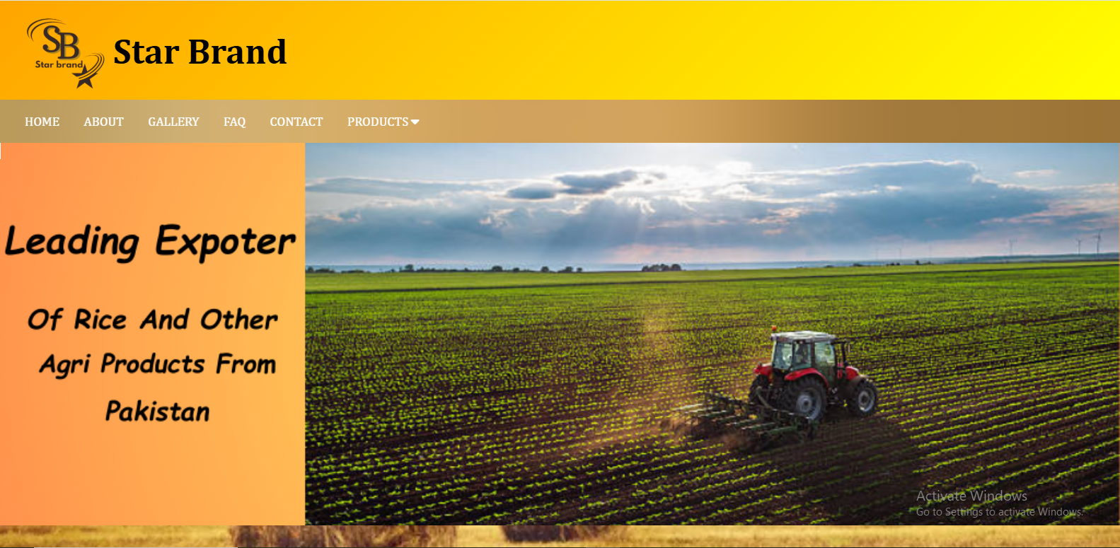

**GALLERY**

Our gallery page lets you explore all our products with ease.  
It’s the only page where you can find the complete range.  
You can view all our products in one place.  
The names of all our products are also displayed there.

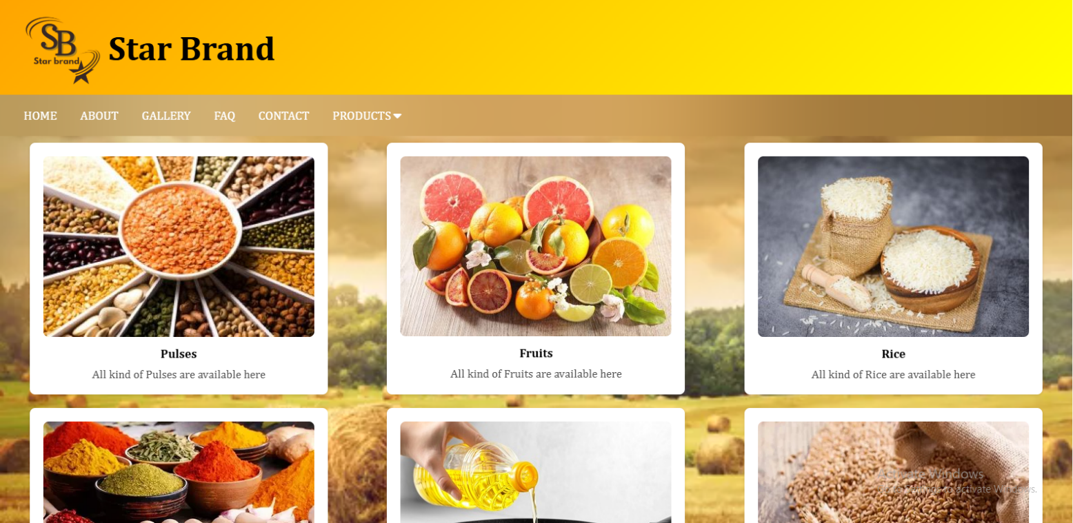

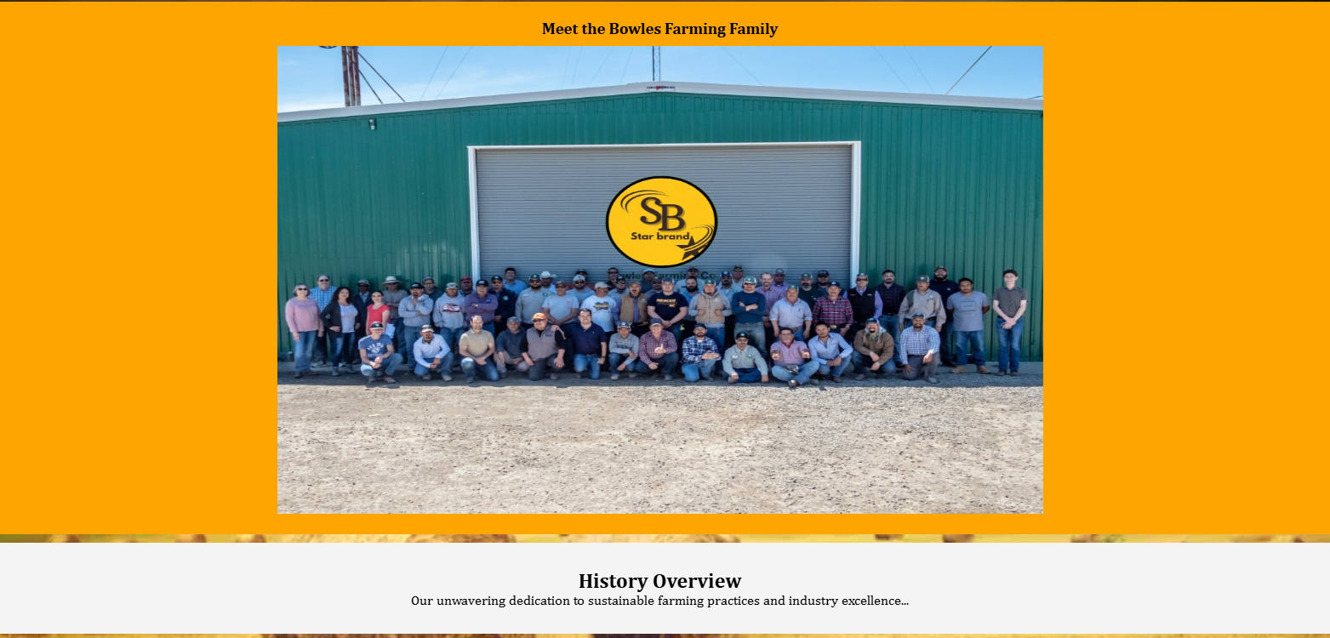

**ABOUT**

In this page user can easily know about our career, our work, our farmers life, our teammates struggle to build a better community. Basically, user can get information about our site only in this page.

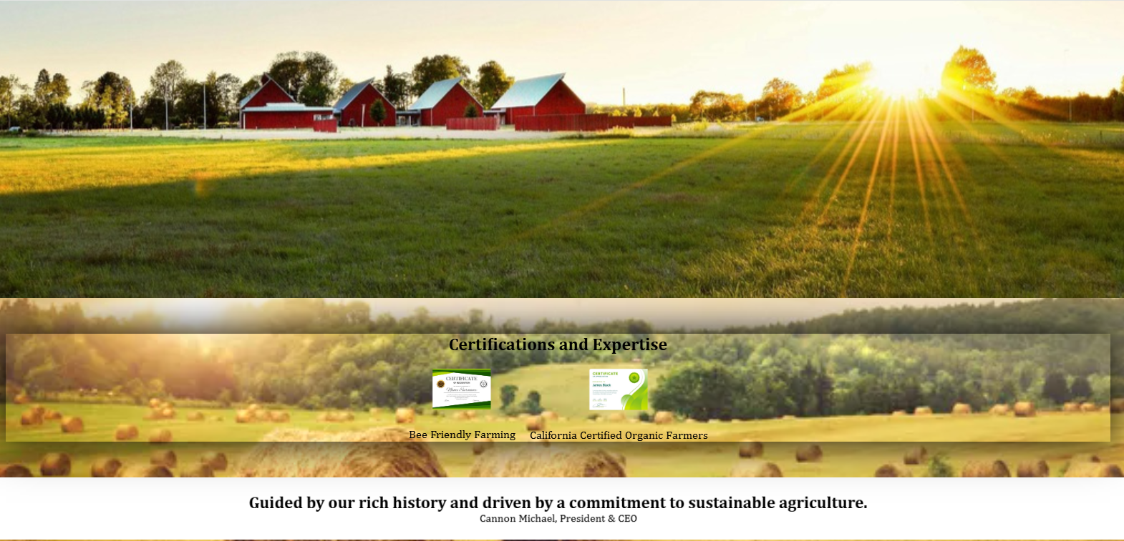

**PRODUCTS**

In this page of product the information about our products and their details, and user can also navigate through cards to products like Rice, Pulses, Spices, Oils etc.

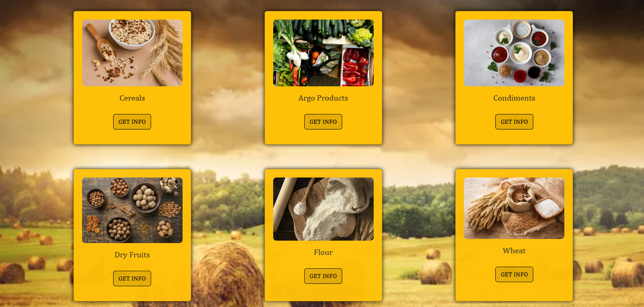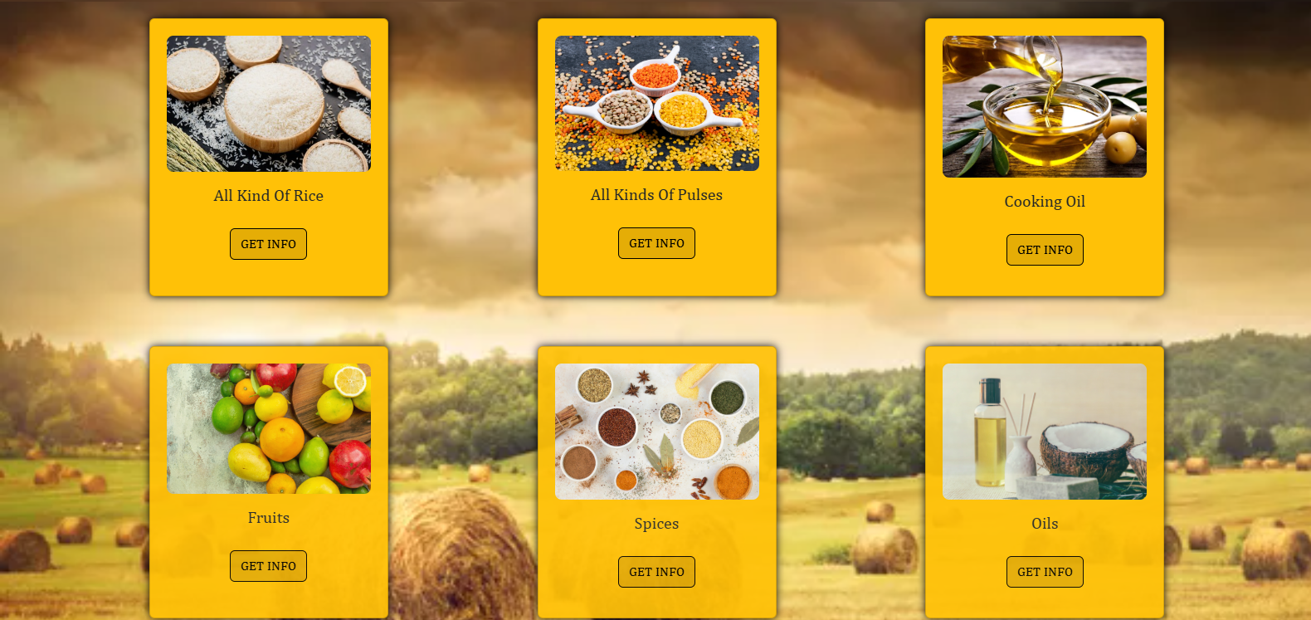

**FAQs**

A list of questions and answers relating to a particular subject, especially one giving basic information for users of a website.

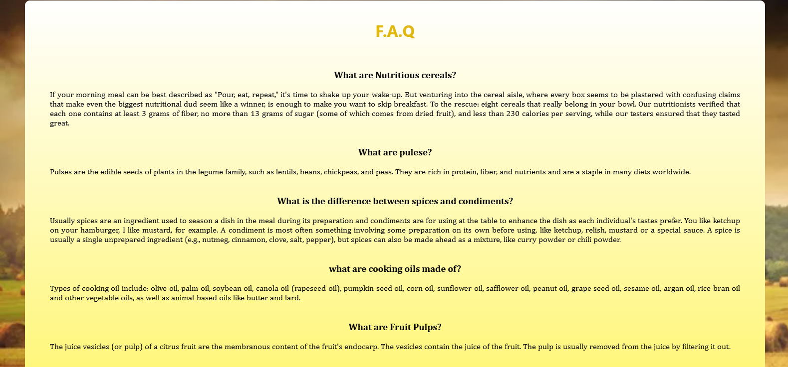

**CONTACT US**

In this page, we add our e-mail, or other personal information that enables other users to get a hold of someone.



